**STUDENT DATA MANAGEMENT SYSTEM**

Project Report

Submitted in Partial Fulfillment of the Requirement for the Degree of

**BACHELOR OF ENGINEERING**

**(Electronics and Telecommunication)**

**MUMBAI UNIVERSITY**

by

**Atharva Deherkar**

**Purva Hambire**

**Sumeet Sharma**

**Kritika Singh**

under the guidance of

**Prof. Fr. Fabian Barreto**

**Prof. Nitin Ahire**

**Prof. Tejal Deshpande**



**Department of Electronics and Telecommunication Engineering**

**Xavier Institute of Engineering**

**Mahim (W), Mumbai - 400016**

**(2020-2021)**

**Project Report Approval for S. E.**

This project report entitled ***Student data management system*** by ***Atharva Deherkar, Purva Hambire, Sumeet Sharma and Kritika Singh*** is approved for the degree of Bachelor of Engineering in Electronics and Telecommunication.

Examiners 1.----------------------------------------

(Name & Sign)

2.---------------------------------------

(Name & Sign)

Supervisors 1.----------------------------------------

(Name & Sign)

2.---------------------------------------

(Name & Sign)

HoD -----------------------------------------

(Name & Sign)

Date:

Place:

# Declaration

I declare that this written submission represents my ideas in my own words and where others’ ideas or words have been included, I have adequately cited and referenced the original sources. I also declare that I have adhered to all principles of academic honesty and integrity and have not misrepresented or fabricated or falsified any idea/data/fact/source in my submission. I understand that any violation of the above will be cause for disciplinary action by the Institute and can also evoke penal action from the sources which have thus not been properly cited or from whom proper permission has not been taken when needed

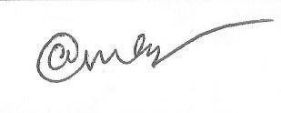-----------------------------------------

(Signature)

_____Atharva Deherkar 08____ (Name of student and Roll No.)

Date:

# Declaration

I declare that this written submission represents my ideas in my own words and where others’ ideas or words have been included, I have adequately cited and referenced the original sources. I also declare that I have adhered to all principles of academic honesty and integrity and have not misrepresented or fabricated or falsified any idea/data/fact/source in my submission. I understand that any violation of the above will be cause for disciplinary action by the Institute and can also evoke penal action from the sources which have thus not been properly cited or from whom proper permission has not been taken when needed 

-----------------------------------------

(Signature)

____Purva Hambire17____ (Name of student and Roll No.)

Date:

# Declaration

I declare that this written submission represents my ideas in my own words and where others’ ideas or words have been included, I have adequately cited and referenced the original sources. I also declare that I have adhered to all principles of academic honesty and integrity and have not misrepresented or fabricated or falsified any idea/data/fact/source in my submission. I understand that any violation of the above will be cause for disciplinary action by the Institute and can also evoke penal action from the sources which have thus not been properly cited or from whom proper permission has not been taken when needed

-----------------------------------------

(Signature)

_____Sumeet Sharma 29_____ (Name of student and Roll No.)

Date:

# Declaration

I declare that this written submission represents my ideas in my own words and where others’ ideas or words have been included, I have adequately cited and referenced the original sources. I also declare that I have adhered to all principles of academic honesty and integrity and have not misrepresented or fabricated or falsified any idea/data/fact/source in my submission. I understand that any violation of the above will be cause for disciplinary action by the Institute and can also evoke penal action from the sources which have thus not been properly cited or from whom proper permission has not been taken when needed

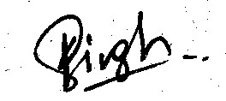

-----------------------------------------

(Signature)

______Kritika Singh 34_____ (Name of student and Roll No.)

Date:

## ABSTRACT

The student data management system will help in managing the student’s personal details and exam results. It will also help in saving time, cost and efforts of the teaching and managing staff. The program is user friendly and easy to understand. The information of a student can be obtained with just a click.

## ACKNOWLEDGMENTS

We would like to thank our project guide Fr. Fabian SJ, Prof. Nitin Ahire sir and Prof.

Tejal Deshpande ma’am, who initiated us into the learning C++. They have been a source of inspiration and his insight and vision has made it possible for us to pursue and understand the developments in these areas. Their patience, encouragement, critique and availability made this dissertation possible.

We are also grateful to Xavier Institute of Engineering Management, Principal Dr. Y. D. Venkatesh and especially the Head of the Department Ms. Vidya Sarode and all the faculty and staff who have helped us to be better acquainted with the recent trends in technology and from whom we have learned so much.

Moreover, we are thankful to all our colleagues and friends for the wonderful years and moments spent at XIE. They indeed have transformed our years at XIE into happy memories, memories which will linger on for decades.

Above all we are grateful to our family because of whose motivation and sacrifice we were able to pursue our Engineering studies. We are immensely grateful to our parents for their sacrifices and encouragement. We can never forget the dreams they have for us and the support they gave us from the very first day they held our hand and led us to school. We hope in the years to come our achievements will indeed make them proud.

**CONTENTS**

|  |  |  |  |
| --- | --- | --- | --- |
| 1 |  | **Introduction** | 1 |
|  | 1.1 | Motivation and Background | 1 |
|  | 1.2 | Objective | 1 |
|  | 1.3 | Outline and Scope | 1 |
|  | 1.4 | Time Plan | 2 |
|  |  |  |  |
| 2 |  | **Concepts Used** |  |
|  | 2.1 | Different Concepts used | 3 |
|  | 2.2 | Explanation of concepts | 3 |
|  |  |  |  |
| 3 |  | **Code** |  |
|  | 3.1 | Code for the project | 4 |
|  |  |  |  |
| 4 |  | **Output of the code** | 9 |
| 5 |  | **Conclusion** | 13 |
| 6 |  | **References** | 14 |
|  |  |  |  |

**List of Figures**

|  |  |  |
| --- | --- | --- |
| Figure No | Caption | Page No |
| 1.1 | Time plan | 2 |
| 4.1 | Choosing your option | 9 |
| 4.2 | Creating a record | 10 |
| 4.3 | Displaying information | 11 |
| 4.4 | Updating information | 12 |

**Chapter 1**

## Introduction

### 1.1. Motivation and Background

The student management system is been developed to eliminate the need of maintaining records manually thus helping the institution to increase their productivity, reduce the time and cost factors associated with the system. Manual record keeping also had several problems like storing, editing the information and managing so many records.

Automation of records makes it easier to tackle the above problems.

### 1.2. Objective

The objective of our project is to create a simplified record system for institutions which can eliminate the need of physical record keeping and make tasks easier and faster. This project can be used by exam and admissions department to store marks and basc information of any student.

### 1.3. Outline and scope

This dissertation report consists of six chapters. The contents of the chapters are as follows:

Chapter 2 helps us to understand the concepts which are used in the program.

Chapter 3 shows the code of our Student management system.

Chapter 4 displays the output of the program.

Chapter 5 concludes our project.

### 1.4. Time plan

The time plan for our project is described in Fig. 1.1

|  |  |  |  |  |  |
| --- | --- | --- | --- | --- | --- |
|  | August | September | October | November | December |
| Selection of Topic |  |  |  |  |  |
| Literature Survey |  |  |  |  |  |
| Abstract |  |  |  |  |  |
| Implementation I |  |  |  |  |  |
| Report I |  |  |  |  |  |
| Implementation II |  |  |  |  |  |
| Report II |  |  |  |  |  |
| Final Black Book Report |  |  |  |  |  |

Fig. 1.1 Project time plan

## Chapter 2

### 2.1 Concepts used in the project-

* If-else
* Switch case

**2.2 A short explanation of concepts used-**

### (A) If else-

1. Use if to specify a block of code to be executed, if a specified condition is true
2. Use else to specify a block of code to be executed, if the same condition is false
3. Use else if to specify a new condition to test, if the first condition is false
4. Use switch to specify many alternative blocks of code to be executed

### (B) Switch case-

1. The switch expression is evaluated once.
2. The value of the expression is compared with the values of each case.
3. If there is a match, the associated block of code is executed.
4. The break and default keywords are optional-

-When break is reached in the program, the program breaks out of the switch block.

-The default keyword specifies some code to run if there is no case match.

**Chapter 3**

## CODE OF THE STUDENT MANAGEMENT SYSTEM

#include<iostream> using namespace std;

#include<conio.h>

class student {

protected:

int rno; char

fname[10],lname[10],cource[20],dob[15],mo[15],addr[20],city[10],email[30]; int sub1, sub2, sub3, sub4, sub5, sub6, total; float per; public:

void input_details()

{

cout<<"\n\n Enter Roll No ===>";

cin>>rno;

cout<<"\n";

cout<<"\n\n Enter First Name ===>";

cin>>fname; cout<<"\n";

cout<<"\n\n Enter Last Name ===>";

cin>>lname; cout<<"\n";

cout<<"\n\n Enter Year ===>";

cin>>cource;

cout<<"\n";

cout<<"\n\n Enter Date Of Birth ===>";

cin>>dob;

cout<<"\n";

cout<<"\n\n Enter Mobile No ===>";

cin>>mo;

cout<<"\n";

cout<<"\n\n Enter Address ===>";

cin>>addr;

cout<<"\n";

cout<<"\n\n Enter City ===>";

cin>>city;

cout<<"\n";

cout<<"\n\n Enter Email ===>";

cin>>email; cout<<"\n";

cout<<"\n\nEnter the Marks of Electronic devices and circuits ==>";

cin>>sub1;

cout<<"\n";

cout<<"\n\nEnter the Marks of Digital system design ==>";

cin>>sub2;

cout<<"\n";

cout<<"\n\nEnter the Marks of Network Theory ==>";

cin>>sub3;

cout<<"\n";

cout<<"\n\nEnter the Marks of Electronic

instruments and control systems ==>";

cin>>sub4;

cout<<"\n";

cout<<"\n\nEnter the Marks of Skill lab ==>";

cin>>sub5;

cout<<"\n";

cout<<"\n\nEnter the Marks of Engineering

Mathematics ==>";

cin>>sub6;

cout<<"\n";

total=sub1+sub2+sub3+sub4+sub5+sub6;

per=total/6;

}

void output_details()

{

cout<<"\tXavier Institue of Engneering"<<endl; cout<<"\n___________________________"<<endl; cout<<"\n Roll No :---> "<<rno; cout<<"\n First Name :---> "<<fname; cout<<"\t\t Last Name :---> "<<lname; cout<<"\n Year :---> "<<cource; cout<<"\t Date Of Birth :---> "<<dob; cout<<"\n Mobile No :---> "<<mo; cout<<"\t\t Address :---> "<<addr; cout<<"\n City :---> "<<city;

cout<<"\n Email :---> "<<email;

}

void output_marksheet()

{

cout<<"\n___________________________"<<endl;

cout<<"Subject

total marks obtained marks"<<endl;

cout<<"___________________________"<<endl;

cout<<" Marks of Electronic devices and circuits

100 "<<sub1<<endl;

cout<<"Marks of Digital system design

100 "<<sub2<<endl;

cout<<"Marks of Network Theory

100 "<<sub3<<endl;

cout<<"Marks of Electronic instruments and control

systems 100 "<<sub4<<endl;

cout<<"Marks of Skill lab

100 "<<sub5<<endl;

cout<<"Marks of Engineering Mathematics

100 "<<sub6<<endl;

cout<<"Percentage

100 "<<per<<endl;

cout<<"___________________________"<<endl;

cout<<"Total Marks

600 "<<total;

if(per>=90 && per<=100)

{

cout<<"\n\n\t\t Your Grade is :----> A+";

cout<<"\n";

}

else if(per>=80 && per<=90)

{

cout<<"\n\n\t\t Your Grade is :----> A";

cout<<"\n";

}

else if(per>=70 && per<=80)

{

cout<<"\n\t\t Your Grade is :----> B+";

}

else if(per>=60 && per<=70)

{

cout<<"\n\t\t Your Grade is :----> B";

}

else if(per>=50 && per<=60)

{

cout<<"\n\t\t Your Grade is :----> C";

}

else if(per>=40 && per<=50)

{

cout<<"\n\t\t Your Grade is :---->D";

}

else

{

cout<<"\n\t\t You Are Fail......";

}

}

};

class master : virtual public student

{

public: void create()

{

cout<<"\n\n===========================> Insert

Information <==========================\n\n";

input_details();

}

void display()

{

cout<<"\n\n=========================> Summary Report

<============================\n\n";

output_details();

cout<<"\n\n=========================> Student Marksheet

Report <==========================\n\n";

output_marksheet();

cout<<"\n\n\t=========================> End Of Marksheet

<==========================\n\n";

cout<<"\n\n\t=========================> End of Report

<=============================\n\n";

}

void update()

{

int choice;

cout<<"\n\n\t=========================> Update

Information <=========================\n\n";

cout<<"\n\n\t ---------------> choose Details You Want to Perform <--------------\n\n";

cout<<"\n\n Roll No ===>"<<rno<<"\n"; cout<<"\n\n First Name ===>"<<fname<<"\n"; cout<<"\n\n Last Name ====>"<<lname<<"\n"; cout<<"\n\n Year ===>"<<cource<<"\n"; cout<<"\n\n Date Of Birth ===>"<<dob<<"\n"; cout<<"\n\n Mobile No ===>"<<mo<<"\n"; cout<<"\n\n Address ===>"<<addr<<"\n"; cout<<"\n\n City ===>"<<city<<"\n"; cout<<"\n\n Email ===>"<<email<<"\n";

cout<<"\n\n Electronic devices and circuits marks

===>"<<sub1<<"\n";

cout<<"\n\n Digital system design

marks===>"<<sub2<<"\n";

cout<<"\n\n Network Theory marks===>"<<sub3<<"\n";

cout<<"\n\n Electronic instruments and control systems marks marks===>"<<sub4<<"\n";

cout<<"\n\n Skill lab Marks ===>"<<sub5<<"\n"; cout<<"\n\n Engneering Mathematics Marks

===>"<<sub4<<"\n";

cout<<"\n\n Enter Your Choice ====>";

cin>>choice; switch(choice)

{

case 1:

cout<<"\n\n Enter Roll No :--->";

cin>>rno; cout<<"\n"; break; case 2:

cout<<"\n\n Enter First Name :--->";

cin>>fname; cout<<"\n"; break; case 3:

cout<<"\n\n Enter Last Name :--->";

cin>>lname; cout<<"\n"; break; case 4:

cout<<"\n\n Enter Year :--->";

cin>>cource; cout<<"\n"; break; case 5:

cout<<"\n\n Enter Date Of Birth :--->";

cin>>dob; cout<<"\n"; break; case 6:

cout<<"\n\n Enter Mobile No :--->";

cin>>mo; cout<<"\n"; break; case 7:

cout<<"\n\n Enter Address :--->";

cin>>addr; cout<<"\n"; break; case 8:

cout<<"\n\n Enter city :--->";

cin>>city; cout<<"\n"; break; case 9:

cout<<"\n\n Enter Email :--->";

cin>>email; break; case 10:

cout<<"\n\n Enter Marks Of Electronic devices and circuits :--->";

cin>>sub1; break; case 11:

cout<<"\n\n Enter Marks of Digital system design :--->";

cin>>sub2; cout<<"\n"; break; case 12:

cout<<"\n\n Enter Marks of Network Theory

:--->";

cin>>sub3; cout<<"\n"; break;

case 13:

cout<<"\n\n Enter Marks of Electronic

instruments and control systems :--->";

cin>>sub4; cout<<"\n"; break; case 14:

cout<<"\n\n Enter Marks of Skill lab :---

>";

cin>>sub4; cout<<"\n"; break; case 15:

cout<<"\n\n Enter Marks of Engneering

Mathematics :--->";

cin>>sub4; cout<<"\n"; break; default:

cout<<"\n\n=======> Invalid Choice

<=========\n *** Try again ***\n\n";

break;

}

}

}; int main()

{

master ms; while(1)

{

cout<<"\n\n\t **** Choose Operation You Want To Perform

****\n\n";

cout<<"\n\n\t\t 1--> Create Record"; cout<<"\n\n\t\t 2--> Update Record"; cout<<"\n\n\t\t 3--> Display Record"; cout<<"\n\n\t\t 4--> Exit Program";

cout<<"\n\n Enter your choice====>";

int ch;

cin>>ch; switch(ch)

{

case 1: ms.create(); break; case 2: ms.update(); break; case 3:

ms.display(); break; case 4:

goto out; default:

cout<<"\n\n\t========> Invalid choice <========";

break;

}

}

out:

getch();

}

## Chapter 4

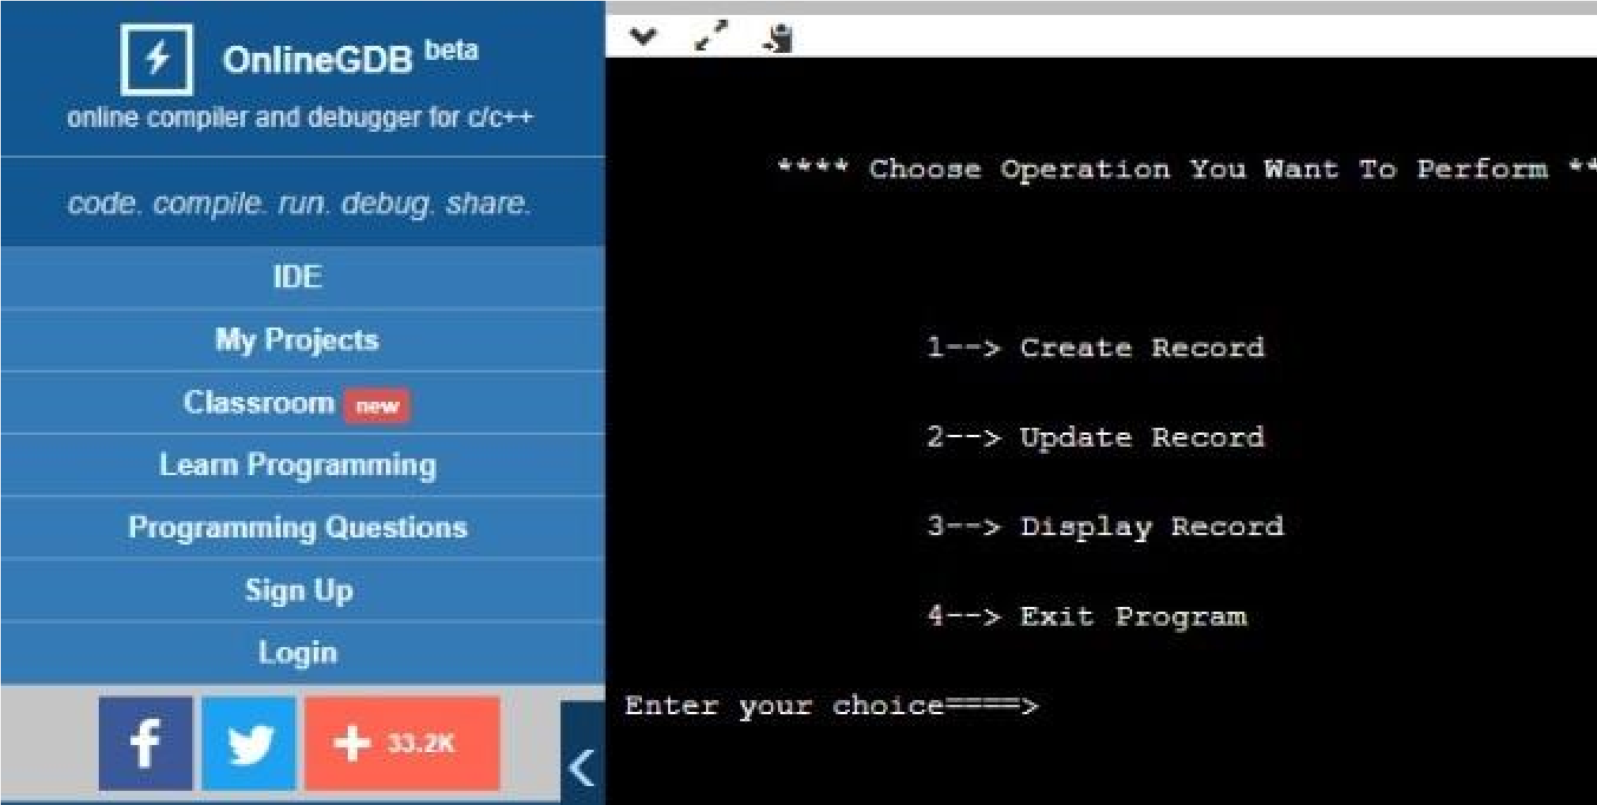**OUTPUT OF THE CODE**

### Fig 4.1 choosing your option

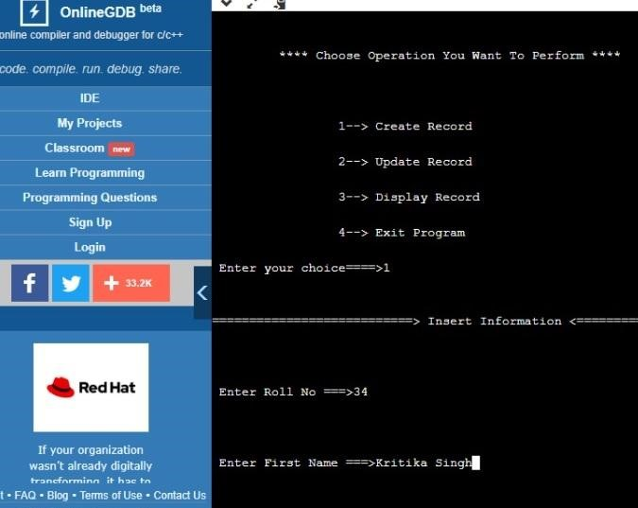

**Fig 4.2 creating record**

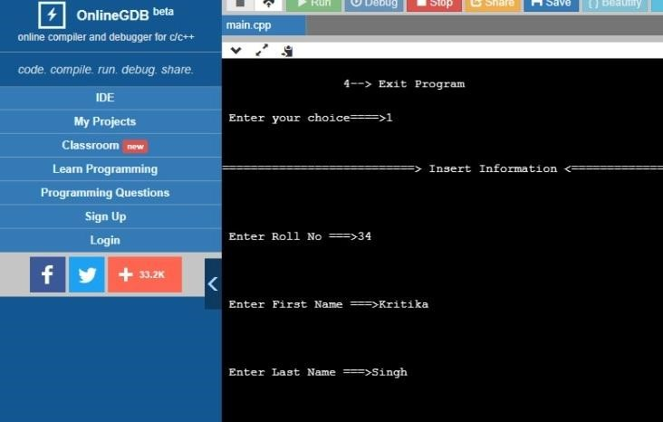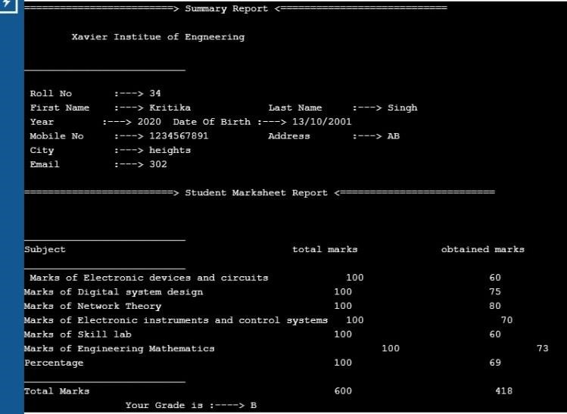

**Fig 4.3 Displaying record**

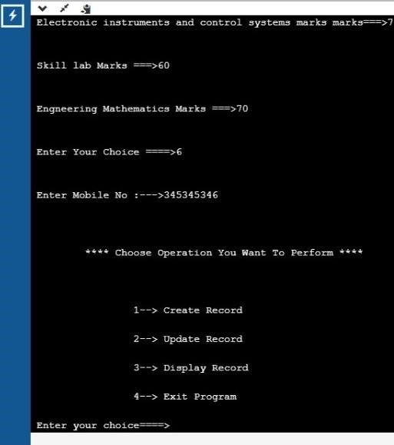

**Fig 4.4 updating response**

**Chapter 5**

## CONCLUSION

Our project is only a humble venture to find a solution for automation of recordkeeping in schools and colleges for one student using very user friendly coding.

Student Management System can be used by educational institutions to maintain their student records easily. Achieving this objective is difficult using the manual system as the information is scattered, can be redundant and collecting relevant information may be very time-consuming.

All these problems are solved by this project. This system helps in maintaining the information of pupil of the organization. It can be easily accessed by the manager and kept safe for a long period of time without any changes.

## REFERENCES

1. **Lovely coding** - https://www.lovelycoding.org/student-management-system/.
2. **Jisschool -**https://jischoolerp.com/blog/55/impact-of-school-managementsystem-on-the-school-development
3. **W3schools** - https://www.w3schools.com/cpp/cpp_switch.asp

https://www.w3schools.com/cpp/cpp_conditions.asp.